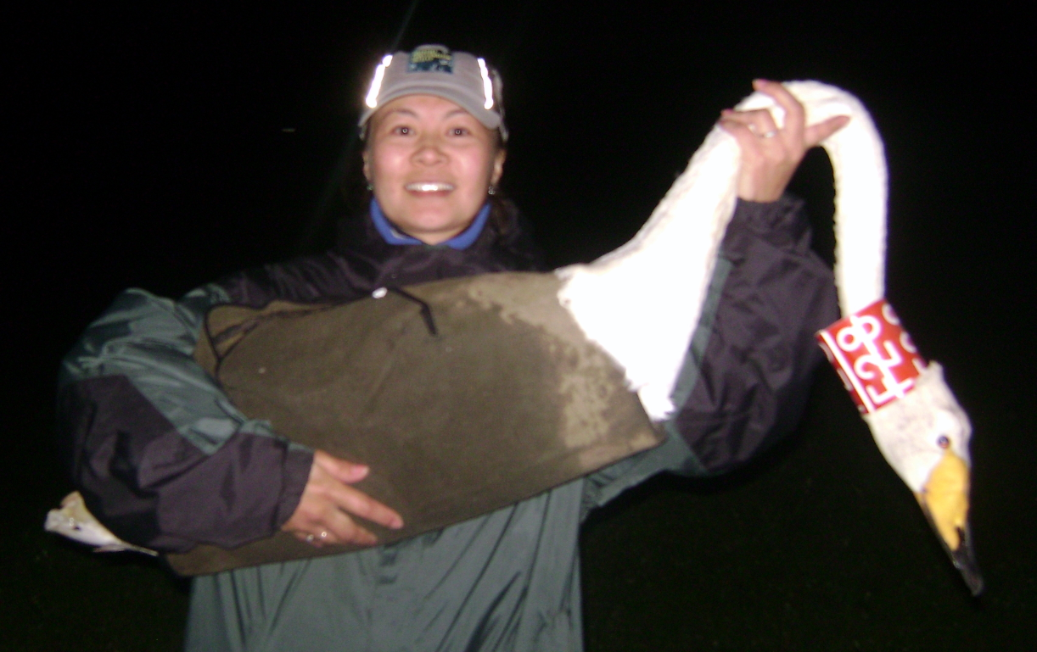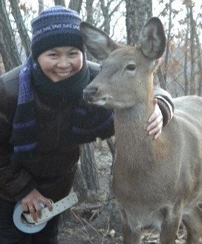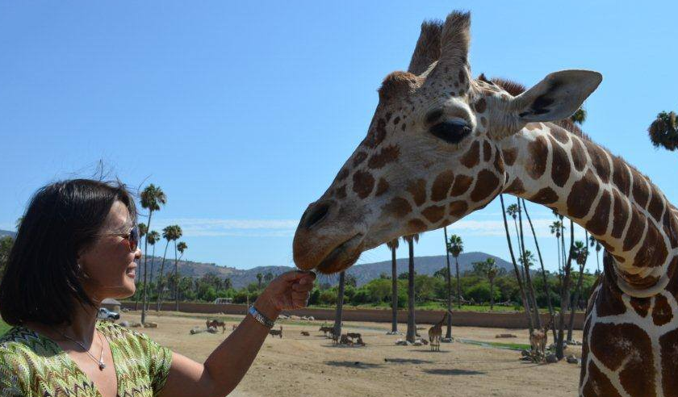

Enkhtuvshin Shiilegdamba
USAID in Mongolia, One Health Consultant
Dr. Enkhtuvshin Shiilegdamba is a graduate from the School of Veterinary Medicine and Biotechnology of the State Agriculture University of Mongolia.
She obtained a Masters of Preventive Veterinary Medicine and Epidemiology (MPVM) degree from the University of California in Davis, USA and in 2004-2007, she completed a Post-Doctoral research position at the Western Institute for Food Safety and Security at the University of California in Davis, USA .

She is a wildlife and livestock disease expert. Having worked on the Peste des Petits Ruminants (PPR) outbreak on Saiga antelopes and wild ungulates in Western Mongolia, Foot and Mouth disease research in Mongolian Gazelle, Avian Influenza surveillance in wild migratory birds and also has transboundary animal disease and One Health experience.

She has organized high level decision making and policy support workshops and meetings at local and National level on livestock wildlife disease and management issues, promoted environmental and wildlife friendly disease management activities, supported biodiversity conservation and protection in Mongolia.

