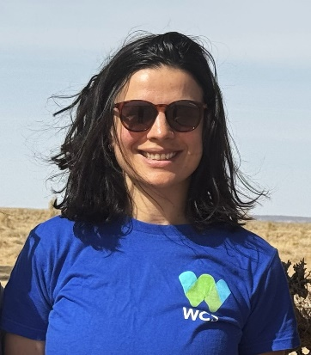
Dr. Justine Shanti Alexander currently serves as the WCS Mongolia Country Director. Prior to this role, she held positions as the Executive Director of the Snow Leopard Network (2020-2023) and Senior Conservation Scientist for the Snow Leopard Trust (2016-2023). Over the past decade, Justine has focused on fostering partnerships at both national and local levels to conserve the threatened snow leopard across High Asia, with a particular emphasis on Mongolia and China. Her conservation efforts involve facilitating connections among government bodies, civil society, and local communities, managing cross-country projects, and strengthening the capacities of national partners. Justine holds a master's degree in Conservation Science from Imperial College (U.K.) in 2011 and completed her Ph.D. on snow leopard conservation at Beijing Forestry University (China) in 2015.

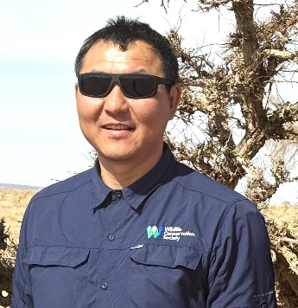
Dr. Buuveibaatar Bayarbaatar, the Habitat Connectivity Program Manager and Senior Scientist at WCS Mongolia Country, brings a wealth of experience in wildlife ecology and Mongolia's biodiversity and ecosystems. Previously, he served as a wildlife biologist at the Institute of Biology, Mongolian Academy of Sciences (2004-2009). With a focus on research and conservation, his main interest centers on mitigating the impacts of linear infrastructures and promoting habitat connectivity, particularly for nomadic ungulate species such as the saiga antelope, Asiatic wild ass, goitered gazelle, and Mongolian gazelle. Buuvei earned his master's (2011) and PhD (2016) degrees from the University of Massachusetts Amherst.

